Northover's VT
Sponsored by Rudy Project

Present their

Easter 10 Mile Time Trials
Event Sponsored by:
Yellow Ltd
Rudy Project

Monday 18th April 2022

Course S26R/10

(Promoted for and on behalf of Cycling Time Trials under
their rules and Regulations)

IN THE INTEREST OF YOUR OWN SAFETY, Cycling Time Trials and the event Promoters now insist that a HARD SHELL HELMET that meets an internationally accepted safety standard be worn. Plus working front and rear lights.

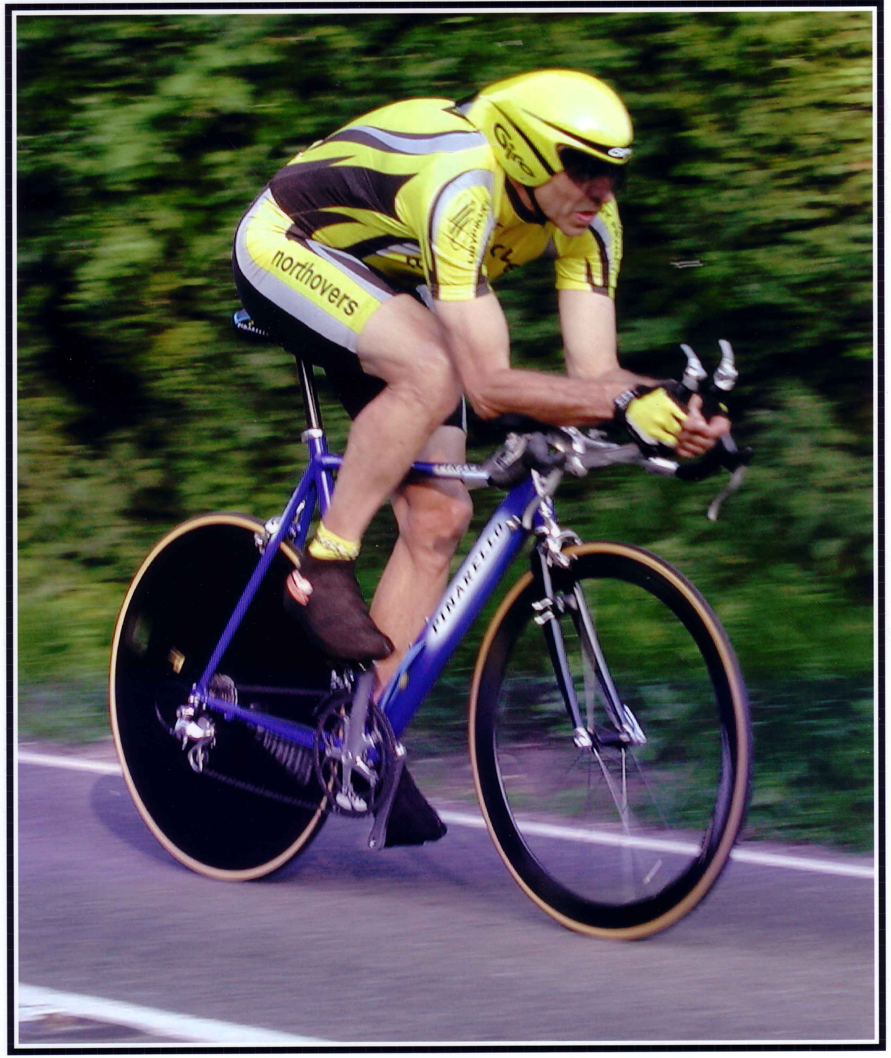

This Northover’s VT 10 Mile Solo & 2up TT is organised in memory of
our team-mate and good friend Bob Redrup.
who passed away unexpectedly on 26 September 2003 whilst on a training ride with the team prior to the Duo Normandy in Marigny, France.

Easter Solo & 2Up 10 Mile Time Trial

Course Details: S26R/10

Event HQ Organiser Timekeepers

Feniton Village Hall Tom Cox Andy Greatwood
Feniton, Nr Honiton 54 Graham Way Dennis Davies
Devon Cotford St Luke
Somerset TA4 1JG

If the car park is full in the village and ride down to the changing rooms – try to leave the church clear, it would be nice if there is space near the church for the elderly residents to park – thank you

Prize List Men- Solo
1st £25 – George Kimber Spirit BSS 19:06
2nd £20 – Tom Scorer RNRMCA 19:38
3rd £15 – James Pearcy Mid Devon CC 20:37

1st Vet 40+ £10 – Tim Southcombe SRC 21:21
1st Vet 50+ £10 Gavin MacDougall RNRMCA 21:17
1st Vet 60+ £10 – Ian Deakin Mid Devon CC 25:37
1st Schoolboy £10 – Joseph Martindale Chip & Dist Whlrs 25:32

Prize List – 2up
1st Club Team or Composite £25 – T Scorer & G MacDougall RNRMCA 20:23
2nd Club Team or Composite £20 – O Pennington 1st Chard & G Kimber Spirit BSS 20:36
3rd Club Team or Composite £15 – L Martindale Chip & Dist Whlrs & R Symington 21:07

Prize Winners – All prize winners above would you please send me your bank details and I will arrange to do a transfer.

NB: One Rider on Prize – As a result no Junior Prize awarded in solo event as our Junior rider came 3rd Overall so the higher values prize was awarded instead

Thanks

I would just like to say a big thanks to our time keepers Andy Greatwood and Dennis Davies along with their assistants John Williams and Sue Gould. Also to Peter and Ruth Rogers along with Angie Simpson who did the marshalling on the return leg coming off the 303. Our turn marshals, Sally Hutter and Mrs O along with Mike Rose who also put the large signs out. To our HQ staff my wife Rosemary along with Ray and Lesley Pollard a big thanks to all. without you these events would not run.

Last but not least thanks to all the riders hope to see you next year same place different time as this is a traditional Easter Monday event.

Pictures

Mrs O our photographer extraordinaire has asked me to convey to all riders that she has taken pictures these can be seen on her FB Page or on Flicker at the following link https://flic.kr/s/aHBqizL74Z . Many thanks Ann its always great to see the pictures.

